AI BASED MULTI-FEATURED AGRICULTURE RECOMMENDATION SYSTEM FOR
CROP MANAGEMENT AND PRICE PREDICTION

A PROJECT rEPORT
Submitted by
KIRAN A - 510822205018
SANJAY D - 510822205040
SARAVANAN K - 510822205041
in partial fulfillment for the award of the degree
of
BACHELOR OF TECHNOLOGY
IN
INFORMATION TECHNOLOGY
GANADIPATHY TULSI’S JAIN ENGINEERING COLLEGE
KANIYAMBADI, VELLORE – 632 102.
ANNA UNIVERSITY : CHENNAI 600 025
APRIL 2026
ANNA UNIVERSITY : CHENNAI 600 025
BONAFIDE CERTIFICATE
Certified that this project report “AI BASED MULTI-FEATURED AGRICULTURE RECOMMENDATION SYSTEM FOR CROP MANAGEMENT AND PRICE PREDICTION” is the bonafide work of “KIRAN A [510822205018], SANJAY D [510822205040], SARAVANAN K [510822205041]” who carried out the project work under my supervision.

SIGNATURE SIGNATURE
D. DURAI KUMAR D. DURAI KUMAR
SUPERVISOR HEAD OF THE DEPARTMENT Associate Professor Associate Professor
Department of Information Technology Department of Information Technology Ganadipathy Tulsi’s Jain Engineering College Ganadipathy Tulsi’s Jain Engineering College Kaniyambadi, Vellore – 632 102. Kaniyambadi, Vellore – 632 102.

Submitted for the Project Viva-Voce Examination held on ……….…

INTERNAL EXAMINER EXTERNAL EXAMINER
ACKNOWLEDGEMENT

ABSTRACT
An Artificial Intelligence based Multi-Featured Agricultural Recommendation System (ARS) is an Intelligent Recommendation System that uses AI Algorithms in order to assist the farmers in Precision Agriculture. In India, the farmer community is composed mainly of small and marginal farmers who majorly face many challenges in agriculture. The major cause of these challenges is mainly due to lack of proper awareness, less adoption of modern technologies, lack of capital or gap between farmers and agricultural market. So bridging the gap between rural farmers, government and financial institutions is highly required for best crop management and price prediction. The existing ARS primarily focus on isolated functionalities, implemented as independent and standalone solutions. However, they fail to correlate these recommendations with logistic costs, input availability, market demand, inflation, and government policies, which are essential for profit-oriented and precision agriculture. Currently the farmer is required to consult multiple platforms to access different types of information, leading to fragmented decision making. Hence the proposed system provides a unified solution through an intelligent and data-driven informed decision to the farmers for betterment of precision agriculture, improving yield prediction, reducing decision uncertainty, and supporting sustainable agricultural practices which have been faced by existing systems. The proposed approach employs multiple ML & DL models to capture complex interrelationships among agronomic, climatic, and market factors, thereby enabling highly better predictions and data-driven, actionable recommendations for effective agricultural planning.

TABLE OF CONTENTS
CHAPTER NO TITLE PAGE NO
ABSTRACT iii
LIST OF FIGURES vii
LIST OF ABBREVIATIONS viii
1 INTRODUCTION 1
1.1 OBJECTIVE 1
1.2 OVERVIEW 2
2 LITERATURE REVIEW 3
2.1 EXISTING SYSTEM 13
2.2 PROPOSED SYSTEM 14
3 PROBLEM STATEMENT 15
4 PROBLEM ANALYSIS 16
5 SYSTEM SPECIFICATION 18
5.1 HARDWARE REQUIREMENTS 18
5.2 SOFTWARE REQUIREMENTS 18
5.3 SOFTWARE DESCRIPTION 19
5.3.1 Python 19
5.3.2 FastAPI 20
5.3.3 TensorFlow 20
5.3.4 SQLite 21
5.3.5 React 21
6 SYSTEM DESIGN 22
6.1 DATA FLOW DIAGRAM
OVERVIEW 23
7 PROJECT DESCRIPTION 25
7.1 MODULES 25
7.1.1 Agricultural Data Collection 25
7.1.2 Raw Data Preprocessing 26
7.1.3 Feature Engineering 26
7.1.4. Correlation & Integration 27
7.1.5 Multi-Model Prediction 28
7.1.6 Crop & Price Recommendation 28
8 SYSTEM IMPLEMENTATION 30
8.1 AGRICULTURE DATA COLLECTION
MODULE 30
8.2 RAW DATA PREPROCESSING
MODULE 33
8.3 FEATURE ENGINEERING
MODULE 39
8.4 CORRELATION & INTEGRATION
MODULE 43
8.5 MULTI-MODEL PREDICTION
MODULE 45
8.6 CROP &PRICE RECOMMENDATION
MODULE 48
9 SYSTEM TESTING 54
9.1 TESTING 54
9.2 TESTING METHODOLOGY 54
9.3 TESTING OF CLASSIFICATION
MODELS 54
9.4 TESTING OF REGRESSION
MODELS 57
9.5 API TESTING 59
10 CONCLUSION 62
APPENDICES 63
APPENDIX 1: SOURCE CODE 63
APPENDIX 2: SCREEN SHOTS 66
REFERENCES 70

LIST OF FIGURES
FIGURE NO TITLE PAGE NO
6.1 Level 0 Data Flow Diagram 22
6.2 Level 1 Data Flow Diagram 22
6.3 Overall Data Flow Diagram 23

LIST OF ABBREVIATIONS
ARS Agricultural Recommendation System
ML Machine Learning
DL Deep Learning
HTML Hypertext Markup Language
CSS Cascade Style Sheet
CSV Comma-Separated Values
GUI Graphical User Interface
API Application Programming Interface
ANN Artificial Neural Network
CNN Convolutional Neural Network
SVM Support Vector Machine
LSTM Long Short-Term Memory
GRU Gated Reccurrent Unit
GBM Gradient Boosting Machine
SARIMA Seasonal Auto Regressive Integrated Moving Average
MSE Mean Squared Error
RMSE Root Mean Squared Error
MAE Mean Absolute Error
IQR Interquartile Range
HTTP Hypertext Transfer Protocol
JSON JavaScript Object Notation

CHAPTER 1
INTRODUCTION
Agriculture remains a critical sector for economic stability and food security in India, where a majority of farmers are small and marginal landholders who face persistent challenges such as limited access to resources, inadequate market awareness, unpredictable climatic conditions, and low adoption of modern technologies. These challenges often result in suboptimal crop selection, poor yield outcomes, and unstable market returns. Existing Agricultural Recommendation Systems (ARS) offer solutions in isolated domains such as crop suggestion, soil analysis, or price forecasting but they operate independently and fail to integrate essential factors like logistics, input availability, market volatility, inflation trends, and government policies. This fragmentation leads to inconsistent decision-making and restricts the practical benefits for farmers. To address these limitations, this work proposes a Artificial Intelligence–based Multi-Featured Agricultural Recommendation System designed to provide a unified and intelligent decision-support framework. By leveraging multiple ML & DL models, the system captures complex temporal relationships among climatic, agronomic, and market parameters, enabling precise predictions and actionable recommendations. The proposed ARS aims to strengthen precision agriculture practices, improve profitability, reduce decision uncertainty, and support farmers with a holistic, data-driven solution that bridges the gap between agricultural production and market demand.
1.1 OBJECTIVE
Primary Objective:
- To design and develop a machine learning–based recommendation system for effective crop management and accurate price prediction.
Secondary Objectives:
- To provide optimized and data-driven farming recommendations.
- To simplify farmers' access to government schemes and financial benefits, ensuring that no eligible support is missed.
1.2 OVERVIEW
The proposed system is an integrated, machine learning-based agricultural decision support platform designed to provide end-to-end guidance for farmers through a unified framework. Unlike existing fragmented solutions, this system combines multiple agricultural components such as soil analysis, weather forecasting, crop recommendation, fertilizer optimization, pest prediction, yield estimation, and market price forecasting into a single, centralized architecture. The system collects multi-source data including soil parameters (NPK values, pH), climatic conditions (temperature, rainfall, humidity), crop history, and real-time market trends. These inputs are processed using data integration techniques and feature engineering to establish meaningful correlations between agronomic factors and market dynamics. Advanced machine learning models are then applied to generate synchronized outputs across all modules. For example, crop recommendations are aligned with soil health and market demand, fertilizer suggestions are tailored to both crop requirements and environmental conditions, and yield predictions are connected with price forecasting to maximize profitability. The platform is designed to be scalable, user-friendly, and accessible, enabling farmers especially smallholders to make informed, data-driven decisions.

CHAPTER 2
LITERATURE REVIEW
[1] Neelamadhab Padhy, Rasmita Panigrahi, Sunil Bag, “Application of Intelligent Recommendation for Agricultural Information”, IEEE International Conference on Emerging Systems and Intelligent Computing (ESIC), 2025.

Many farmers in India continue to use traditional farming methods, which are time-consuming and limit productivity. Modern agriculture requires analyzing key factors such as weather, soil type, and water quality to make informed decisions about crop selection, fertilization, and cultivation planning. Ineffective decisions in these areas can negatively impact crop production. To overcome these challenges, a deep learning based crop recommendation model is proposed. This model uses environmental, weather, and soil data to provide accurate and personalized crop suggestions. By analyzing inputs like temperature, humidity, soil nutrients, rainfall, and irrigation water quality, the system identifies the most suitable crop for given farm conditions. As a result, farmers can make precise decisions that enhance productivity, increase yield, and reduce production costs.
Advantages
- Data-Driven Decision Making
- Effective & Increased Productivity
- Overcomes Limitations of Traditional Methods
Disadvantages
- Need for Frequent Updates
- Potential Difficulty in User Adoption
- Data Availability and Quality Issues
[2] Anamika Dey; Chandranath Chatterjee; Pabitra Mitra; Sadique Amin; Somrita Sarkar, “ GKANs-KNN: Enhancing Crop Recommendations with Deep Learning ” IGARSS 2025 - 2025 IEEE International Geoscience and Remote Sensing Symposium, 2025.

Sustainable agriculture requires integrating soil and weather data to improve farming decisions and crop productivity. This study presents a precision crop recommendation model that combines a Graph Convolutional Network (GCN) with a Kolmogorov–Arnold Network (KAN), the first of its kind in crop recommendation. A KNN-based adjacency matrix constructs a farming graph based on similarities in environmental and soil conditions. The model analyzes key soil nutrients (N, P, K), pH, and weather factors such as temperature, humidity, and rainfall from various regions in India. The KAN layer enhances the system’s ability to capture complex relationships among soil, climate, and crop types. They have used the following model [GKANs-KNN model achieves 98% accuracy], surpassing existing methods and offering a powerful solution for precision agriculture, crop selection, and resource management.
Advantages
- Multi-Parameter Integration
- Improved Precision Agriculture
- Advanced Modeling of Complex Relationships
- Graph-Based Contextual Understanding
Disadvantages
- Computational Complexity
- Limited Interpretability
- Requires High-Quality, Comprehensive Data.

[3] Ahmad Ali, Asad Gulshair; Atif Khan; Ayesha Khaliq; Muhammad Umair; Salman Jan ; “AI-Driven Smart Agriculture: An Integrated Approach for Soil Analysis, Irrigation, and Crop-Fertilizer Recommendations” IEEE Conference, 2025.

Modern agriculture faces major challenges such as water shortages, poor resource utilization, and declining soil health, which reduce sustainability and crop yields. To address these issues, this study proposes an AI-powered smart agriculture system that integrates deep learning (DL), IoT and explainable AI (XAI) to enable precise, data-driven farming. IoT sensors collect real-time soil data including nutrients, moisture, and temperature while advanced DL models provide specialized recommendations. The system also incorporates weather forecasting through an API and a chatbot interface for enhanced usability. The solution improves productivity, optimizes resource use, and strengthens resilience to environmental changes, contributing to sustainable agriculture and food security.
Advantages
- Real-Time Data Collection
- Explainability
- Resource Optimization
- Improved Productivity
Disadvantages
- High Implementation Cost
- Possible Sensor Failures
- Data Dependency

[4] Renukadevi S; Sanjay M; “Crop Disease Prediction and Pesticide Recommendation Using Deep Learning Techniques” 2025 International Conference on Data Science and Business Systems (ICDSBS), 2025.

Crop diseases pose a major threat to food security by reducing yields and lowering farmers’ incomes. To address this, the system integrates both machine learning and deep learning approaches for identifying crop diseases and recommending suitable pesticides, using image data collected from Ghanaian farms. The system trains models such as Random Forest, SVM, and KNN, as well as advanced deep learning architectures including a Customized VGG16 and a Fine-tuned Customized Vision Transformer. After applying image preprocessing and augmentation techniques, the Vision Transformer model achieved the highest accuracy, offering fast and reliable disease detection. By delivering accurate diagnoses and appropriate pesticide suggestions, the system enhances crop management, supports sustainable farming, and helps reduce food shortages caused by severe plant diseases.
Advantages
- Fast and Automated Diagnosis
- Better Pesticide Recommendations
- Improved Productivity
- Sustainability Support
Disadvantages
- Potential Misclassification
- High Cost Implemenatation

- Akhil Kumar M B; Anirudh T G; Chinmay S Jain; Karthik K S; Mallikarjun B C; “ Smart Agriculture with Fertilizer/Pesticide Recommendation System ”, 2025 3rd International Conference on Smart Systems for applications in Electrical Sciences (ICSSES), 2025.

This article presents a Smart Agriculture System designed to enhance crop productivity through precision farming. Using NPK and soil moisture sensors, the system gathers real-time information on soil nutrients and moisture levels, transmitting the data via LoRa technology, which enables efficient long-distance communication without the need for internet access. A deep learning model analyzes the incoming sensor data to generate optimized recommendations for fertilizer and pesticide usage, as well as optimal irrigation levels. The system combines AI-based decision-making with LoRa communication to deliver real-time, reliable insights, validated through extensive field testing. Overall, it enables precise soil analysis, improved resource management, increased crop yields, and supports scalable, eco-friendly agricultural practices suitable for various field sizes and crop types.
Advantages
- Long-Range, Internet-Free Communication
- Real-Time Soil Monitoring
- AI-Driven Recommendations
Disadvantages
- Limited LoRa Coverage in Some Regions
- Technical Knowledge Needed
- Initial Setup Costs

[6] Bixian Cheng; Danni Chen; Ji Li ; Jun Liu ; Qing Shen; “A study on the forecasting of agricultural product price trends based on SARIMA”, 2025 IEEE 8th Information Technology and Mechatronics Engineering Conference (ITOEC), 2025.

Agriculture plays a vital role in national stability and public well-being, especially with grain and oil products whose price fluctuations significantly influence the economy. This system applies the SARIMA model to forecast price trends of key agricultural products by analyzing monthly price data from 2018 to 2022 released by the National Bureau of Statistics of China. Through examining seasonal variations in products such as rice and rapeseed, the model captures their characteristic price patterns and uses them to predict future fluctuations. The results demonstrate that the SARIMA model provides high accuracy, strong fitting performance, and satisfies residual normality assumptions, making it a reliable tool for forecasting agricultural price trends. Its use can support government decision-making, stabilize markets, and help to protect farmers interests.
Advantages
- Captures Seasonality Effectively
- Interpretable Model
- Works Well with Limited Data
- Useful for Policy and Decision-Making
Disadvantages
- Requires Stationary Data
- Difficult to Handle Sudden Market Shocks
- Less Effective for Nonlinear Relationships

[7] Anitha C; Kavitha U; Poornachandra T; Rajasekar G; Saravanan T R ; Sathishkumar V E “IoT-based Gradient Boosting Model for Efficient Agricultural Logistics and Transport Management”, 2025 4th International Conference on Innovative Mechanisms for Industry Applications (ICIMIA), 2025.

Efficient logistics are crucial in agriculture to minimize post-harvest losses and improve supply chain performance. This study presents an IoT-enabled Gradient Boosting Model (GBM) that enhances agricultural logistics by integrating real-time sensor data collected over six months from GPS modules, temperature and humidity sensors, and load cells installed on transport trucks and storage units. Using 15,000 data samples from 120 delivery routes, GBM achieved an accurate prediction of delivery delays, outperforming Random Forest and SVM. The system optimized routing, reducing fuel consumption by 17.3% and lowering delivery time by 22.8%. Cold-chain integrity improved to 96.5%, far exceeding the baseline 87.9%. Overall, combining IoT data with GBM significantly improves logistics decision-making, enhances efficiency, reduces operational costs, and preserves the quality of agricultural produce, offering a scalable and data-driven solution for managing agricultural transportation networks.
Advantages
- Real-Time Monitoring
- Improved Supply Chain Efficiency
- Reduced Operational Costs
Disadvantages
- Dependence on Network Connectivity
- Technical Complexity
- High Initial Setup Cost
[8] Claudio Salvadori; Cristiana Caponio; Eddi Lorenzi; Fabrizio Benelli; Franco Maciariello; Giovanna Sangiuolo; “TrackOne: Smart Logistics for a Sustainable and Interoperable Agricultural Supply Chain in the Era of Digitization“, 2025 International Conference on Software, Telecommunications and Computer Networks (SoftCOM), 2025.

TrackOne is an affordable and GDPR-compliant logistics system made for agricultural supply chains. It uses IoT devices, the Hyperledger Fabric blockchain, and GS1 EPCIS 2.0 standards to track products in real time. Unlike traditional systems that only monitor basic data like RFID tags or temperature, TrackOne collects richer information such as ethylene levels, weight, and GPS location. This helps predict product quality, reduce waste, and extend shelf life. The system supports EU goals like the Physical Internet and the circular economy by encouraging data-driven decisions in agriculture. Tested on 127 smart containers for 179 days, TrackOne showed strong performance with 2.3-second traceability, over 1,200 transactions per second, and 93.4% accuracy in detecting anomalies, proving it is effective for modern, sustainable agri-food logistics.
Advantages
- Real-Time Traceability
- Blockchain-Based Security
- Multimodal Data Fusion
Disadvantages
- Implementation Complexity
- Inconsideration of Inflation

- Mohammed Hamzah ; Sakthi ; Syed Fawaz Ahmed “ FutureCrop: AI-Powered Price Prediction for Agriculture and Vegetable Markets ”, IEEE International Journal of Scientific Development and Research , 2025.

Predicting agricultural commodity prices helps farmers, traders, and policymakers make better decisions. This system builds a machine learning model using Convolutional Neural Networks (CNN) to forecast the prices of important crops like pulses, vegetables, and cereals. The CNN model studies past price data along with weather and market trends to find patterns and make accurate predictions. It works better than traditional methods, especially with large and complex data. The system is easy to use and provides real-time price forecasts, helping farmers reduce financial risk and plan their activities more effectively. This approach supports stable markets and encourages smarter, more sustainable farming decisions.
Advantages
- Improved price forecasting
- Supports data-driven decisions
- Captures nonlinear patterns
- Enhances market transparency
- Real-time analytics
Disadvantages
- High data dependency
- Potential forecasting errors
- Technical complexity

- Lingfang Zhao; Xingbo Yao ; Yan Lu; Yihua Wang; Ziyun Ding; “Simulation of Agricultural Product Price Forecast and Market Analysis Model Based on Time Series Algorithm”, 2024 International Conference on Telecommunications and Power Electronics (TELEPE), 2024.

The simulation models to predict agricultural product prices and understand market trends using a combined time-series method that integrates ARIMA and SARIMA. After collecting and cleaning large sets of price data, the researchers analyze it and apply the hybrid model. Simulation results show that this combined approach gives more accurate predictions than traditional methods. The study also finds seasonal patterns in the data, tunes model parameters using grid search and automated tools, and tracks how prediction accuracy changes over time. Overall, they have used the following model to improve forecasting precision, detects seasonal effects more effectively, and enhances parameter optimization. This provides useful data support for better agricultural market management and more informed decision-making.
Advantages
- Effective Seasonal Pattern Detection
- Data-Driven Decision Support
- Useful for Trend Analysis
Disadvantages
- High Data Requirements
- Computational Cost
- Potential Overfitting

2.1 EXISTING SYSTEM
The system operates by integrating multiple agricultural decision-making components into a structured workflow. Climatic factors such as temperature, rainfall, humidity, and seasonal patterns are analyzed to identify crops that are best suited to prevailing environmental conditions.
Based on the selected crop and observed soil and climate parameters, fertilizer recommendations, irrigation scheduling, and pest control measures are generated using predefined agricultural rules and expert knowledge. Crop yield estimation is performed by learning patterns from historical production data, taking into account factors such as weather trends, soil fertility, and past yields.
For market-oriented insights, statistical time-series models such as ARIMA and SARIMA are employed to forecast short-term trends in crop prices using historical market data. Each module crop recommendation, input management, yield prediction, and price forecasting functions in a coordinated manner, enabling the system to provide comprehensive, data-driven guidance to support informed agricultural planning and decision-making.
Advantages:
- Data-Driven Decision Making
- Suitable for limited data
- Easy implementation
Disadvantages:
- Solutions isolation
- Cannot handle sudden shocks
- Features unrelated

2.2 PROPOSED SYSTEM
The proposed system presents a unified intelligent framework that seamlessly integrates crop management and agricultural price prediction to support end-to-end decision-making for farmers. It aggregates heterogeneous data sources, including soil characteristics, climatic conditions, crop attributes, historical production records, and economic and market indicators, into a single correlated data pipeline.
The system employs a combination of machine learning and deep learning models to capture complex non-linear relationships among agricultural variables and to learn temporal patterns across seasons and market cycles. Classical machine learning models such as Random Forest, Support Vector Machines, and Gradient Boosting are used for crop suitability analysis, fertilizer and pesticide recommendation, and yield estimation, while deep learning models such as LSTM and GRU are applied to sequential data for weather-driven growth analysis and market price forecasting. Convolutional Neural Networks are utilized where spatial or image-based inputs such as soil maps, crop images, or satellite data are available, enabling automated feature extraction.
These models operate collaboratively within the framework, sharing learned insights across modules to improve overall prediction consistency. By correlating production-side factors with market-side dynamics, the system generates accurate forecasts for yield, disease risk, irrigation requirements, and market prices, thereby optimizing resource utilization, improving food security, and enhancing farmer profitability. Ultimately, the system empowers farmers to make informed decisions regarding crop selection, cultivation timing, input management, and optimal selling periods to maximize returns.

CHAPTER 3
PROBLEM STATEMENT
Here we have Identified to Major Problems, which are:
- Fragmented Agricultural Decision Support
Fragmented Agricultural Decision Support refers to the way many existing agricultural systems function as standalone tools, each addressing a specific aspect such as crop selection, fertilizer recommendation, yield estimation, or market price forecasting independently. These systems do not share inputs or outputs with one another, resulting in disconnected recommendations that farmers must manually interpret and combine. As a result, decision-making becomes complex, as insights related to climate, soil, crop management, and market trends are delivered separately rather than as a unified, end-to-end guidance framework.
- Uncorrelated Agricultural Factors
Uncorrelated Agricultural Factors further characterize current systems, where critical variables such as soil health, weather conditions, crop growth stages, input usage, yield outcomes, and market prices are analyzed in isolation. The absence of structured relationships among these factors prevents holistic analysis and limits the ability to model real-world agricultural dynamics accurately. Without correlating production-side parameters with market-side indicators, precision agriculture solutions remain partial, reducing their effectiveness in supporting integrated crop management and reliable price prediction within a single decision-support ecosystem.

CHAPTER 4
PROBLEM ANALYSIS
Fragmented Agricultural Decision Support refers to the existence of multiple standalone agricultural systems, each focusing on a single function such as crop selection, fertilizer recommendation, yield estimation, or market price forecasting. These systems operate independently without sharing inputs or outputs, resulting in disconnected and inconsistent recommendations for farmers. This problem arises due to the isolated development of agricultural technologies, where each platform is designed to solve a specific objective rather than providing an integrated solution. The absence of unified architecture and lack of interoperability between systems force farmers to manually interpret and combine multiple outputs, increasing complexity and the chances of poor decision-making. The issue can be addressed by developing a centralized, integrated decision support system that unifies all agricultural modules into a single framework. By enabling communication between crop, soil, weather, pest, yield, and market components, the system can deliver synchronized, end-to-end recommendations. This integration will simplify decision-making and improve the efficiency of precision agriculture.
Uncorrelated Agricultural Factors refer to the lack of meaningful relationships between critical variables such as soil nutrients (NPK), pH levels, weather conditions, crop growth stages, input usage, yield outcomes, and market prices. These factors are analyzed independently, limiting the ability to generate accurate and holistic insights. This issue occurs because agricultural datasets such as soil data, climate data, yield records, and market trends are handled separately without proper integration or feature correlation. The absence of structured relationships prevents systems from capturing real-world dependencies between production conditions and market dynamics, resulting in incomplete and less reliable recommendations. The problem can be overcome by implementing a multi-source data integration approach combined with machine learning techniques. By performing feature engineering and correlating agronomic parameters with market indicators, a unified analytical framework can be developed. This enables accurate predictions, optimized crop planning, and better alignment between production and market demand, leading to more effective precision agriculture solutions.

CHAPTER 5
SYSTEM SPECIFICATION

5.1 HARDWARE REQUIREMENTS:
The proposed Agricultural Recommendation System is designed to operate efficiently on standard computing infrastructure, making it accessible and cost-effective for deployment in rural and institutional environments.
- Processor : Intel Core i3 / i5 or equivalent (minimum)
- RAM : 8 GB (minimum), 16 GB (recommended for
model training)
- Storage : 256 GB HDD/SSD (minimum)
- GPU (Optional) : NVIDIA GPU (for faster LSTM model training)
- Input Devices : Keyboard, Mouse
- Output Devices : Monitor / Mobile Display
- Network : Stable Internet connection for real-time data
access

5.2 SOFTWARE REQUIREMENTS:
The system uses open-source and widely adopted technologies to ensure scalability, flexibility, and ease of maintenance.
- Operating System : Windows 10 / 11 (Or) Linux (Ubuntu 20.04 or
later)
- Prog. Language : Python 3
- ML Libraries : TensorFlow / Keras (LSTM implementation),
Scikit-learn
- Data Visualization : Matplotlib, Seaborn
- Backend Frameworks : Flask / Django, Node.js
- Frontend Technologies : HTML, CSS, JavaScript, React.js
- Database : MySQL / PostgreSQL, MongoDB
5.3 SOFTWARE DESCRIPTION:
5.3.1 Python:
Python is a powerful, high-level programming language created by Guido van Rossum and released in 1991. It supports various programming styles, including procedural, object-oriented, and functional programming. Due to its simplicity and rich libraries, it is widely used in AI, web development, automation, and data science.
Key Features:
• Simple, clean, and readable code.
• Portable and scalable.
• Strong standard library.
• GUI and web development support.
• Ideal for both small and large projects.
Pandas:
Pandas are a fast, powerful, flexible and easy to use open-source data analysis and manipulation tool, built on top of the Python programming language. pandas are a Python package that provides fast, flexible, and expressive data structures designed to make working with "relational" or "labelled" data both easy and intuitive. It aims to be the fundamental high-level building block for doing practical, real world data analysis in Python.
Numpy:
NumPy, which stands for Numerical Python, is a library consisting of multidimensional array objects and a collection of routines for processing those arrays. Using NumPy, mathematical and logical operations on arrays can be performed. NumPy is a general-purpose array-processing package. It provides a high-performance multidimensional array object, and tools for working with these arrays.
Scikit Learn:
Scikit-learn is a Python module for machine learning built on top of SciPy and is distributed under the 3-Clause BSD license. Scikit-learn is a free software machine learning library for the Python programming language. It features various classification, regression and clustering algorithms including support vector machines, random forests, gradient boosting, k-means and is designed to interoperate with the Python numerical and scientific libraries NumPy and SciPy.
5.3.2 FastAPI :
FastAPI is a modern, high-performance web framework used for building APIs with Python. It was created by Sebastián Ramírez and is designed for developing fast and efficient backend services. FastAPI is widely used for developing RESTful APIs that handle data processing, machine learning model integration, and communication between frontend applications and databases.
5.3.3 TensorFlow:
TensorFlow is an open-source machine learning and deep learning framework developed by Google for building and deploying intelligent models. It allows developers to design neural networks and mathematical models using data flow graphs. TensorFlow supports tasks such as regression, classification, time-series forecasting, and image and speech recognition. It is highly scalable and can run on CPUs, GPUs, and TPUs for faster computation. The framework provides strong support for model training, evaluation, and optimization.
5.3.4 SQLite:
SQLite is a lightweight, open-source relational database management system used to store and manage structured data. It is serverless, meaning it does not re8.3.8quire a separate server process to operate. SQLite stores the entire database in a single file, making it easy to deploy and maintain. It supports standard SQL queries such as SELECT, INSERT, UPDATE, and DELETE. The database is fast and efficient for small to medium-sized applications. SQLite is widely used in mobile apps, desktop software, and embedded systems.
5.3.5 React:
React is an open-source JavaScript library used for building modern and interactive user interfaces, especially for single-page web applications. It was developed and maintained by Meta Platforms. React allows developers to create reusable UI components that efficiently update and render when data changes.

CHAPTER 6
SYSTEM DESIGN
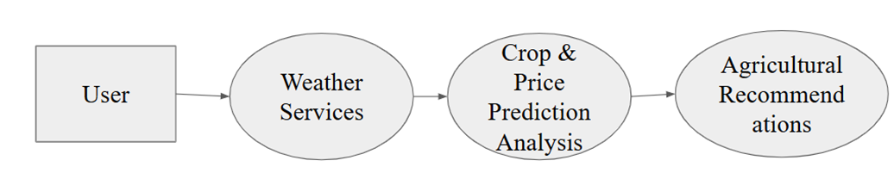
Figure 6.1: Level 0 Data Flow Diagram

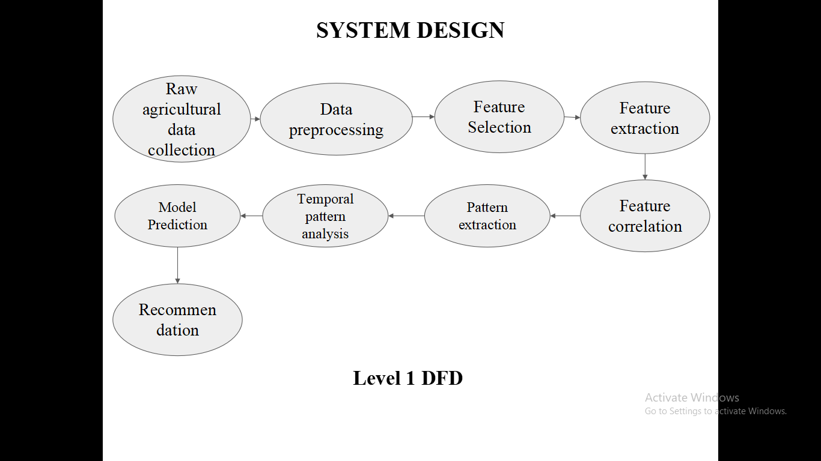
Figure 6.2: Level 1 Data Flow Diagram

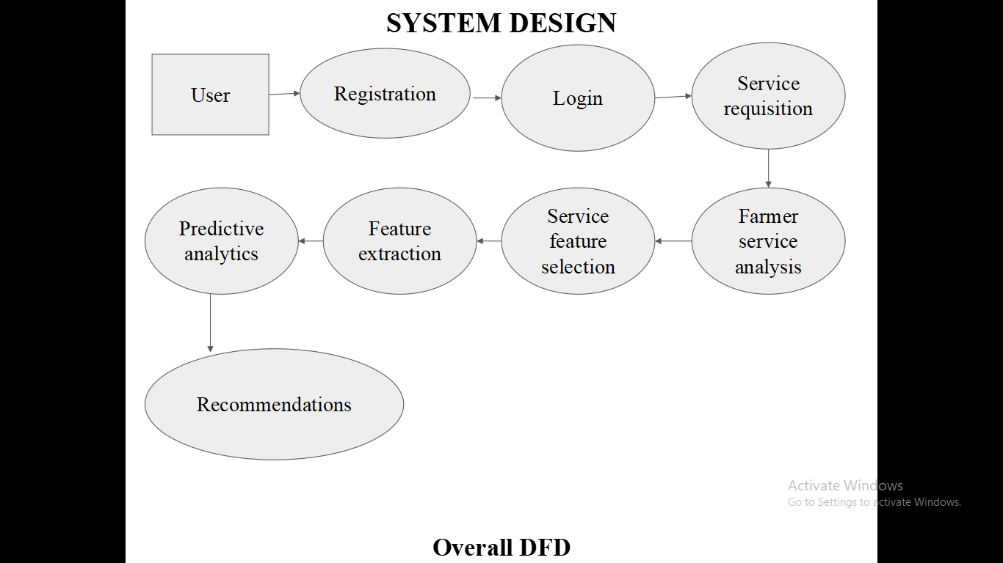
Figure 6.3: Overall Data Flow Diagram
6.1 DATA FLOW DIAGRAM OVERVIEW
The given diagram illustrates the complete workflow of the proposed AI-based crop management and price prediction system, showing how user inputs are processed to generate meaningful recommendations and predictions.
The process begins with the Farmer, who accesses the application and completes the Register process by providing basic user details. Once registered, the farmer performs User Login to securely access the system.
After successful login, the farmer enters farm details, such as crop type, soil characteristics, rainfall, temperature, and other relevant parameters. This farm data is then forwarded to the Pre-trained Machine Learning Model, which has already been trained using historical agricultural and market datasets.
The pre-trained model processes the received farm data and analyzes it by considering multiple factors, including environmental conditions and historical price trends. Based on this analysis, the system predicts suitable outputs such as crop recommendations or expected future prices.
The prediction stage further correlates various factors like climate conditions, crop characteristics, and market behavior to ensure accurate and reliable results. The system then evaluates the overall outcome to verify consistency and prediction quality.
Based on the evaluation, the system generates final recommendations, which may include the most suitable crop to grow or the expected market price. These results are finally delivered to the farmer, helping them make informed decisions related to crop management and selling strategies.
Overall, this flow diagram represents an integrated and intelligent system that combines user interaction, machine learning processing, factor correlation, and evaluation to support effective crop management and price prediction activities.

CHAPTER 7
PROJECT DESCRIPTION
7.1 MODULES
The list of modules used in our project are as follows:
- Agriculture Data Collection Module
- Raw Data Preprocessing Module
- Feature Engineering Module
- Correlation & Integration Module
- Multi-Model Prediction Module
- Crop & Price Recommendation Module

7.1.1 Agricultural Data Collection
The Data Collection module is responsible for gathering diverse agricultural data required for integrated decision-making. Data is collected from multiple reliable sources to support crop recommendation, fertilizer and pesticide suggestion, yield prediction, harvest time estimation, market demand analysis, and price prediction.
The purpose of collecting this data is to create a comprehensive dataset that supports accurate prediction of suitable crops, fertilizer and pesticide usage, expected yield, optimal harvest time, market demand, and future prices.

7.1.2 Raw Data Preprocessing
The Data Preprocessing module prepares the raw agricultural data for analysis and modeling. Since the collected data comes from multiple sources and domains, preprocessing is essential to ensure accuracy and consistency. The processed data is converted into structured formats suitable for machine learning and time-series prediction, ensuring reliable learning and prediction.

7.1.3 Feature Engineering
The Feature Engineering module extracts and constructs meaningful features from preprocessed data to improve prediction accuracy. This module plays a key role in correlating agricultural, environmental, and market factors. These features enable the system to capture non-linear relationships and interdependencies between crop management practices, yield, demand, and pricing.

7.1.4 Correlation & Integration
The Feature Correlation and Integration module analyzes relationships among engineered features to ensure meaningful interaction between agricultural, environmental, and market variables. Since crop management and price prediction are highly interdependent, this module plays a crucial role in unifying multiple data domains.
The output of this module is a correlated and integrated multi-dimensional feature set that accurately represents the interactions between crop management practices and market dynamics, enabling efficient learning by predictive models.

7.1.5 Multi-Model Prediction
The Multi-Model Prediction module focuses on selecting and training suitable machine learning and deep learning models for different agricultural prediction tasks. Since each task has distinct characteristics, multiple models are employed to improve overall system accuracy. This module enables simultaneous prediction of crop suitability, yield, harvest time, demand, and future prices within a unified framework.

7.1.6 Crop & Price recommendation
The Crop and Price Recommendation module converts model predictions into actionable insights for farmers and stakeholders. This module integrates outputs from multiple prediction models to provide optimized recommendations. By correlating crop management decisions with market intelligence, this module ensures farmers receive economically viable and data-driven recommendations that support sustainable and profitable agriculture.

CHAPTER 8
SYSTEM IMPLEMENTATION
8.1 AGRICUTURE DATA COLLECTION MODULE
The Agriculture Data Collection Module plays an vital role in this ARS System, where this Multi-featured System requires an vast amount of data, though this data has been collect from the open source dataset platform called Kaggle. Since some of the some of the attributes which is highly essential for this project are not present in the dataset, so the Synthetic Data Collection is required for the Data Augmentation purpose. The final Dataset contains about 1 lakhs of data samples(rows), and overall 30 attributes(columns), out of which 95% original data and 5% synthetic data. From the collected data the highly impactful features are been used to take major decision for prediction and recommendation(ex: land_acre, NPK, pH, soil_type, rainfall_mm, temperature, season, humidity level, etc…).
The synthetic dataset has designed for the suitable multi-featured system, although the colleted dataset is available in Kaggle dataset since there exists an data scarcity, for that purpose it is gone for the synthetic dataset approach,
/(The AI-based Agriculture Recommendation System for Crop Management & Price Prediction relies heavily on the quality, diversity, and relevance of data, as these factors directly influence the performance of crop recommendation, fertilizer suggestion, yield prediction, logistics optimization, and market price forecasting modules. The primary dataset used in this project, final_concluded_ds_1L.csv, was obtained from Kaggle and consists of 1,00,000 records, of which 95% represent original real-world agricultural data and 5% consist of carefully generated synthetic data. The dataset integrates agricultural, environmental, landholding, and economic parameters necessary for intelligent crop and market decision-making.
Although the Kaggle dataset contained substantial agricultural information, several essential attributes required for the proposed integrated system were missing. These gaps included logistics cost estimation parameters, transport mode–based cost calculation, market distance impact on pricing, farmer category classification based on landholding, yield-to-transport financial linkage, and derived economic indicators such as total production and transport cost. Since the system combines crop recommendation, fertilizer and pesticide suggestion, yield prediction, harvest time estimation, logistics optimization, and market demand and price forecasting within a single framework, enriching the dataset with structured economic and logistics attributes was necessary. Therefore, 5% synthetic data was generated to maintain realism, avoid bias, improve model generalization, simulate real-world variability, and introduce economic and logistics behavior while preserving agricultural consistency.
The final dataset contains 26 attributes categorized into soil parameters (Nitrogen, Phosphorus, Potassium, Soil pH, Soil Type), environmental parameters (Rainfall, Temperature, Humidity, Season), land and farmer information (Land Area, Farmer Category, State, District), crop and yield information (Crop Name, Expected Yield per acre, Total Production), and economic and logistics features (Market Distance, Logistics Type, Transport Rate, Transport Cost, Market Price, Demand Index). Among these, key predictive features include land area (production scale), NPK values (fertilizer recommendation), soil pH and soil type (crop suitability), rainfall and temperature (growth cycle), humidity (pest and yield impact), season (crop compatibility), and market distance and logistics type (cost efficiency). These features serve as primary inputs for Random Forest–based crop recommendation, regression-based yield prediction, time-series price forecasting, and logistics cost optimization.
Synthetic data generation followed controlled probabilistic modeling and rule-based agricultural logic to maintain domain realism. The total production was derived using:
Formula:
Total Production (quintals) = Yield per Acre × Land Area
Code Logic:
- crop_names = list(crop_data.keys())
- total_qtl = yield_final * land_area
This derived feature is essential for revenue prediction, transport cost estimation, and market supply modeling.

Transport cost modeling was structured using predefined rate mapping:
Transport Rate Mapping:
- Tractor → 18.0
- Mini Truck → 15.0
- Truck → 20.0
- Lorry → 20.0
- Railway Freight → 5.0
- Refrigerated Truck → 25.0
Formula:
Transport Cost = Total Quantity × Market Distance × Transport Rate
Code Logic:
- t_rate = transport_rate(logistics_type)
- transport_cost = round(total_qtl * market_km * t_rate, 0)
This structure simulates realistic profitability analysis and logistics optimization, reflecting that railway freight is economical for bulk transport while refrigerated trucks are costly but essential for perishables. Cost increases proportionally with both distance and production volume.
Farmer classification was synthetically generated based on probabilistic landholding ranges:
•Marginal :0.5–2.5acres
•Small :2.5–5.0acres
•Medium :5.0–12.0acres
• Large : >12.0 acres
This classification influences subsidy modeling, crop strategy, production scale, and demand estimation.
To ensure realism, random seeds were fixed for reproducibility, agronomic limits were maintained to control outliers, and correlation consistency was preserved (e.g., high rainfall aligned with suitable crop types, soil pH matched soil type characteristics, NPK values balanced crop requirements, and yield correlated with season and climate). The dataset of 100,000 samples is balanced across seasons, states, soil types, and crop categories, integrating realistic economic modeling. This enriched and augmented dataset supports classification, regression, time-series forecasting, and optimization algorithms. Without this structured data enrichment and synthetic augmentation phase, the integrated agricultural intelligence system would lack economic realism, correlation integrity, and practical scalability.
8.2 RAW DATA PREPROCESSING MODULE
This module focuses on transforming raw agricultural data into a clean, structured, and machine-learning-ready format. Since the performance of crop recommendation, fertilizer suggestion, yield prediction, and market price forecasting models depends heavily on data quality, preprocessing plays a critical role in ensuring reliability and robustness.
This module includes:
- Duplicate removal
- Missing value handling
- Outlier detection
- Categorical encoding
- Standard scaling
- Column transformation pipeline
Duplicate records may occur during data merging, synthetic augmentation, or repeated data entry. These duplicates can:
- Bias the model toward repeated patterns
- Artificially increase the importance of certain crops or regions
- Reduce generalization capability
duplicates = df.duplicated().sum()
- df.duplicated() → Returns Boolean values (True for duplicate rows).
- .sum() → Counts total duplicates.
If duplicates > 0:
df = df.drop_duplicates()
- Ensures unique agricultural samples
- Prevents overfitting
- Maintains realistic data distribution
Agricultural datasets often contain missing values due to:
- Sensor failure (temperature, humidity)
- Soil testing gaps (NPK values)
- Market price recording issues
- Human data entry errors
missing = df.isnull().sum()
- df.isnull() → Identifies missing values.
- .sum() → Counts missing values per column.
Numerical Columns (e.g., rainfall, NPK, temperature)
- Mean Imputation (if normally distributed)
- Median Imputation (if skewed)
- Domain-based imputation (agricultural threshold)
Example:
df['Rainfall_mm'].fillna(df['Rainfall_mm'].median(), inplace=True)
Categorical Columns (e.g., soil_type, season)
- Mode imputation
- "Unknown" category insertion
df['Soil_Type'].fillna(df['Soil_Type'].mode()[0], inplace=True)
- Prevents training errors
- Maintains statistical consistency
- Preserves dataset size
Outliers in agricultural datasets may arise from:
- Abnormal rainfall
- Incorrect NPK measurements
- Extreme yield values
- Erroneous land area entries
To detect outliers, the Interquartile Range (IQR) Method was used.
IQR-Based Outlier Detection Method
def detect_outliers(column):
Q1 = df[column].quantile(0.25)
Q3 = df[column].quantile(0.75)
IQR = Q3 - Q1 # Example: 18 - 7 = 11
outliers = df[(df[column] < Q1 - 1.5 * IQR) | (df[column] > Q3 + 1.5 * IQR)]
return len(outliers)
Mathematical Explanation
- Q1 = 25th percentile
- Q3 = 75th percentile
- IQR = Q3 − Q1
Outlier condition:
Value < Q1 − 1.5 × IQR or Value > Q3 + 1.5 × IQR
Why IQR is Suitable for Agriculture Data
- Robust to skewed distributions
- Handles rainfall variability
- Detects unrealistic land sizes
- Identifies abnormal yield spikes
Treatment of Outliers
- Capping (Winsorization)
- Removal (if extreme)
- Domain thresholding
Example:
upper_limit = Q3 + 1.5 * IQR
lower_limit = Q1 - 1.5 * IQR
df[column] = np.clip(df[column], lower_limit, upper_limit)
Machine learning models cannot directly process categorical strings such as:
- Soil Type (Black, Alluvial, Red)
- Season (Kharif, Rabi)
- Logistics Type (Truck, Railway Freight)
- Crop Name
Therefore, encoding techniques were applied.
Label Encoding (Target Variable)
Used mainly for:
- Crop classification target variable
- Farmer category classification
col_encoded = LabelEncoder().fit_transform(y)
- Converts categories into numeric labels.
- Example:
  - Rice → 0
  - Wheat → 1
  - Maize → 2
- For target variable
- For tree-based models like Random Forest (since they are not distance-based)
Since the system uses multiple ML algorithms (Random Forest, Regression, Neural Networks), feature scaling and categorical encoding must be handled properly.
To automate this, a ColumnTransformer Pipeline was used.
Code Used:
preprocessor = ColumnTransformer(transformers=[
("num", StandardScaler(), numerical_cols_X),
("cat", OneHotEncoder(handle_unknown="ignore"), categorical_cols_X)])
StandardScaler (Numerical Features)
Used for:
- NPK values, Rainfall, Temperature, Humidity, Land Area, Market Distance
Formula:
Z = (X − μ) / σ
- μ = Mean
- σ = Standard deviation
Why is Scaling Important?
- Ensures uniform contribution of features
- Improves neural network convergence
- Stabilizes gradient descent
- Required for distance-based models
OneHotEncoder (Categorical Features) Used for:
- Soil Type, Season, Logistics Type, State, District
Why One-Hot Encoding
- Prevents ordinal bias
- Preserves category independence
- Improves classification performance
handle_unknown="ignore" ensures:
- No error when new unseen category appears during testing
Using ColumnTransformer:
- Avoids data leakage
- Maintains consistent preprocessing for training & testing
- Simplifies model deployment
- Supports multiple ML algorithms
Without proper preprocessing:
- Yield prediction may become unstable
- Crop recommendation accuracy may drop
- Market price forecasting may be biased
- Logistics cost prediction may overestimate or underestimate
8.3 FEATURE ENGINEERING MODULE
The Feature Engineering Module enhances raw agricultural data by transforming existing attributes into more meaningful and model-efficient features. This step improves prediction accuracy for crop recommendation, yield estimation, logistics optimization, and market price forecasting in your integrated agriculture intelligence system.
One important transformation involves categorizing the market distance into meaningful classes. Instead of using raw distance values, a derived categorical feature called Market Distance Category is created. This helps models better understand logistics impact in a structured way.

Feature Selection
Feature Selection is the process of identifying the most important features and removing irrelevant or redundant attributes. Agricultural datasets often contain correlated or less significant variables that may reduce model efficiency and increase computational complexity.
In this agriculture intelligence framework, feature selection can be performed using:
- Feature Importance from Random Forest
- Mutual Information Score
- Recursive Feature Elimination (RFE)
This ensures that crop recommendation, yield prediction, and market forecasting models rely only on the most impactful agricultural parameters.
Market Distance Categorization Logic:
def market_category(km):
if km <= 25:
return "Near"
elif km <= 50:
return "Medium"
else:
return "Far"
df["Market_Distance_Category"]=df["Nearest_Market_km"].apply(market_category)
This feature supports:
- Logistics optimization
- Transport cost modeling
- Market selection strategy
Another critical engineered feature is the Effective Price, which determines the better selling price between the market price and the Minimum Support Price (MSP). Farmers typically choose the higher value to maximize profit, so this feature directly supports revenue modeling.
Effective Price Calculation:
df["Effective_Price"]= df[["Market_Price_INR_per_qtl","MSP_INR_per_qtl"]].max(axis=1)
This feature is essential for:
- Profit prediction
- Revenue optimization
- Market decision modeling
Additionally, total production is derived from yield per acre and land area. This feature links agricultural productivity with economic and logistics modules.
Total Production Calculation:
df["Total_Production_qtl"]=df["Expected_Yield_qtl_per_acre"]*df["Land_Area_acres"])
Formula:
Total Production (quintals) = Expected Yield per Acre × Land Area
This derived feature plays a crucial role in:
- Transport cost estimation
- Supply modeling
- Market demand forecasting
- Farmer income prediction

Feature Extraction
Feature Extraction is the process of identifying and deriving the most relevant information from raw agricultural data to improve model performance. Instead of directly feeding raw variables into machine learning algorithms, important agricultural indicators are extracted and structured into optimized features.
In this agriculture recommendation system, feature extraction includes:
- Soil Nutrient Indicators
Combining Nitrogen (N), Phosphorus (P), and Potassium (K) values to form:
  - Total Nutrient Index
  - NPK Ratio
  - Soil Fertility Score
- Climate-Based Features
Rainfall Category (Low / Medium / High)
Temperature Suitability Index
  - Humidity Stress Indicator
- Land-Based Indicators
  - Farm Size Category (Small / Medium / Large Farmer)
  - Cultivable Efficiency Ratio
- Seasonal Encoding
Transforming seasonal information into numerical form for better model learning.
Feature extraction ensures that the system captures the true agricultural relationships between soil health, climate, crop suitability, and productivity.

8.4 CORRELATION & INTEGRATION MODULE
In the proposed ML-based Agriculture Recommendation System for Crop Management & Price Prediction, feature relationship analysis plays a crucial role in validating the interdependency of agricultural, environmental, and economic parameters. Since the dataset contains both numerical and categorical features, multiple statistical techniques were applied to understand feature interactions. These analyses ensure that the system does not treat agricultural variables independently, but instead models real-world interconnections between soil, climate, yield, logistics, and market price.
Pearson correlation measures the non-linear relationship between numerical variables. This method helps identify how soil nutrients, rainfall, temperature, yield, market price, and profit are interrelated.
# Compute correlation matrix
corr_matrix = df[num_cols].corr(method='pearson')
# Plot heatmap
plt.figure(figsize=(12,8))
sns.heatmap(corr_matrix, annot=True, cmap='coolwarm')
plt.title("Numerical Feature Correlation")
plt.show()
- .corr(method='pearson') computes the Pearson correlation coefficient between all numerical feature pairs.
- A heatmap is generated using Seaborn to visually interpret relationships.
- Values close to +1 indicate strong positive correlation.
- Values close to −1 indicate strong negative correlation.
- Values near 0 indicate weak or no linear relationship.
The results demonstrate that soil nutrients (NPK), rainfall, and temperature strongly influence yield, while yield and market price directly impact revenue and profit. This validates the interdependent nature of agricultural decision-making.
df["Soil_Climate_Score"]=(df["NPK_Total"]*df["Climate_Index"])
This feature captures the interaction between soil fertility and climate conditions, improving crop suitability modeling.
Yield–Market Integration
df["Revenue"]=df["Expected_Yield_qtl_per_acre"]*df["Market_Price_INR_per_qtl"])
Revenue is directly proportional to production and market price. This feature connects agronomic output with economic outcome.
df["Profit_Efficiency"] = (df["Overall_Profit"] /(df["Land_Area_acres"] + 1))
This calculates profit per acre, acting as an efficiency metric for farmer performance evaluation.
To visualize full-system integration, key engineered and core features were analyzed together.
important_features=["NPK_Total","Climate_Index","Expected_Yield_qtl_per_acre", "Market_Price_INR_per_qtl", "Revenue", "Overall_Profit"]
plt.figure(figsize=(8,6))
sns.heatmap(df[important_features].corr(),annot=True, cmap="viridis")
plt.title("Integrated Feature Correlation")
plt.show()
- Selected critical agronomic and economic variables.
- Computed correlation matrix for integrated features.
- Visualized interactions to confirm cross-domain relationships.
The heatmap demonstrates that soil fertility and climate affect yield, yield influences revenue, and revenue drives overall profit. This confirms that the proposed system effectively integrates agricultural and economic intelligence rather than treating modules independently.
The correlation and feature interaction analysis validates that soil, climate, yield, logistics, and market price are statistically and logically interconnected. By applying Pearson correlation, Cramér’s V, ANOVA, and cross-feature engineering, the system ensures robust modeling of real-world agricultural behavior. This integrated analytical framework strengthens classification models, regression models, time-series forecasting, and optimization algorithms within the agriculture recommendation system.

8.5 MULTI-MODEL PREDICTION MODULE
The Multi-Model Prediction Module is designed to apply multiple machine learning and deep learning techniques to predict key agricultural outcomes such as crop type, yield, harvest time, market demand, and price trends. This module uses historical agricultural data and follows a structured pipeline including preprocessing, feature selection, model training, and evaluation.
Instead of using a single model, multiple models are implemented for different prediction tasks. This improves accuracy and ensures that each agricultural problem is handled using the most suitable algorithm.
The dataset is initially preprocessed by handling missing values and converting categorical variables into numerical format using encoding techniques. This step ensures that the data is suitable for machine learning models.
Input Features(X): Soil nutrients (NPK), pH, rainfall, temperature, humidity, etc.
Target Variables(Y): Crop, Expected Yield, Price, Harvest Time, Market Demand
For crop recommendation, a classification algorithm is used. The model learns relationships between environmental factors and suitable crops. The training process involves feeding input features such as soil nutrients and climate conditions into the model. The model then predicts the most suitable crop category.
Yield prediction is handled using regression techniques, where the model predicts the expected crop yield based on input conditions. The model identifies patterns between environmental features and historical yield data. It then outputs a continuous numerical value representing the expected production.
The price prediction model forecasts future market prices based on agricultural and market-related features. This model helps farmers understand potential profit outcomes. It uses regression techniques to analyze past trends and predict future price values.
Harvest time prediction estimates the number of days or months required for a crop to reach maturity. A regression model is trained using features like crop type, temperature, rainfall, and soil conditions. The model learns how these factors influence crop growth duration. This prediction is crucial for planning irrigation, labor, and logistics. The model performance is evaluated using MSE.

Market demand prediction can be handled in two ways depending on the dataset:
If demand is represented as numerical values, a regression model is used to predict future demand levels based on historical trends. If demand is categorized (e.g., Low, Medium, High), a classification model is used to predict the demand category. This prediction helps farmers decide which crops are more profitable based on market needs.
In addition to traditional machine learning models, a deep learning model is implemented to enhance prediction performance.
A neural network with multiple layers is trained using normalized input data. It captures complex nonlinear relationships between agricultural factors and outputs such as yield or harvest time.
The deep learning model is particularly useful when dealing with large and complex datasets. Its performance is compared with machine learning models to select the best approach.
The best-performing models are selected based on their evaluation scores and integrated into the system for real-time predictions.
The Multi-Model Prediction Module generates the following outputs:
- Recommended crop type
- Expected crop yield
- Estimated harvest time
- Predicted market demand
- Forecasted market price
These outputs are further used by the recommendation system to assist farmers in making informed agricultural and financial decisions.
By combining multiple machine learning and deep learning models, this module provides a comprehensive prediction system. It not only improves accuracy but also ensures that all major agricultural factors are interconnected. This integrated approach helps farmers optimize productivity, reduce risk, and maximize profit.
8.6 CROP & PRICE RECOMMENDATION MODULE
The Crop Recommendation and Price Prediction Module serves as the final integration layer of the system. This module combines all previously developed machine learning and deep learning models into a single user-accessible platform. It allows farmers or agricultural stakeholders to input soil, climate, and market-related information and receive intelligent recommendations about suitable crops and predicted market prices.
The module is implemented as a complete web application, where the frontend is developed using React and Tailwind CSS, the backend is implemented using FastAPI, and the data is managed using an SQLite database. The system architecture ensures smooth interaction between the user interface, prediction models, and stored data, enabling real-time decision support.
The platform follows a three-layer architecture:
Frontend Layer – User interface for data input and result visualization.
Backend Layer – API server that processes requests and runs prediction models.
Database Layer – Stores user inputs, prediction results, and historical records.
The interaction flow works as follows:
- Users enter agricultural parameters through the frontend interface.
- The frontend sends the input data to the backend through REST APIs.
- The backend processes the data and passes it to trained ML/DL models.
- The models generate predictions such as crop recommendation and price forecast.
- Results are stored in the database and returned to the frontend for display.
Frontend Layer
The frontend of the system is built using React, which provides a dynamic and interactive user interface. Tailwind CSS is used for styling, enabling responsive and visually clean layouts.
The frontend includes several components that guide the user through the system:
Input form component collects agricultural parameters from the user. The inputs include:
Soil nutrient values (NPK), Soil pH level, Temperature and humidity, Rainfall data, Market distance and logistics parameters
The form validates the inputs before sending them to the backend to ensure correct data formatting.
Once the user submits the form, the frontend sends a POST request to the backend API endpoint. The request contains all input values in structured JSON format. This communication is handled using HTTP request libraries commonly used in React applications.
After the backend returns prediction results, the frontend dynamically updates the interface to display:
Recommended crop, Predicted crop yield, Estimated harvest time, Predicted market demand, Forecasted crop price
The results are displayed using responsive cards and tables styled with Tailwind CSS to improve readability.
Backend Layer
The backend of the system is implemented using FastAPI, a modern Python framework designed for building high-performance APIs. The backend acts as the central controller that connects the user interface with machine learning models and the database.
The backend exposes REST API endpoints that handle requests from the frontend. The main endpoint processes prediction requests. When input data is received, the backend performs the following steps:
- Validates the incoming data using defined data schemas.
- Preprocesses the input features to match the format used during model training.
- Passes the processed data to trained machine learning models.
- Collects predictions from multiple models.
- Returns the combined result to the frontend.
The backend loads previously trained models during server initialization. These models include:
- Crop recommendation model (classification)
- Yield prediction model (regression)
- Harvest time prediction model (regression)
- Market demand prediction model (regression)
- Price prediction model (regression)
Each model processes the input data and returns predictions. The backend aggregates these outputs into a single response object.
When the API receives input data:
- The backend converts the input into a structured feature vector.
- The feature vector is passed through preprocessing steps such as scaling or encoding.
- Each model generates a prediction.
- The predictions are compiled into a response structure and sent back to the frontend.
Database Layer
The system uses SQLite as a lightweight relational database for storing system data. SQLite is chosen because it is simple to configure, requires no external server, and is well suited for prototype or research projects.
The database stores the following information:
All user-submitted agricultural parameters are stored for reference and analysis. This enables tracking of how recommendations were generated.
The outputs generated by the machine learning models are stored alongside user inputs. This helps maintain a history of recommendations and predictions.
Basic logs such as request timestamps and prediction outcomes are stored for monitoring system usage.
The database tables are designed with structured fields representing soil parameters, environmental factors, predicted crop, and price values.
The platform integrates all components into a unified pipeline:
User Interaction:
- The user accesses the web application through a browser.
- Agricultural parameters are entered through the input form.
Frontend to Backend Communication:
- The frontend sends the data to the FastAPI backend through an API request.
Prediction Processing:
- The backend preprocesses the input and runs the machine learning models.
Database Storage:
- Inputs and prediction results are stored in the SQLite database.
Response Generation:
- The backend sends the prediction results to the frontend.
Result Visualization:
- The frontend displays the recommended crop and predicted market price to the user.
This integrated workflow ensures that all modules of the system function together efficiently.
The Crop Recommendation and Price Prediction Platform provides several important capabilities:
- Integrated agricultural decision support system
- Real-time prediction using machine learning models
- User-friendly interface for farmers
- Storage of prediction history and input data
- Scalable architecture for future enhancements
The Crop Recommendation and Price Prediction Module successfully integrates machine learning models into a complete web-based decision support system. By combining a modern frontend interface, a high-performance backend API, and a structured database system, the platform provides a scalable and user-friendly solution for agricultural prediction and recommendation. This module represents the final step in transforming data-driven agricultural models into a practical tool that can assist farmers in improving productivity and maximizing profit.

CHAPTER 9
SYSTEM TESTING
9.1 TESTING
System testing is an essential phase in the development of the Agricultural Recommendation System. The objective of this phase is to evaluate the performance, accuracy, and reliability of the machine learning and deep learning models implemented in the system. The models developed for crop recommendation, yield prediction, harvest time estimation, demand prediction, and price forecasting are tested using appropriate evaluation techniques.

9.2 TESTING METHODOLOGY
The dataset used in the project is divided into training data and testing data. The training data is used to train the machine learning and deep learning models, while the testing data is used to evaluate their predictive performance.
Typically, the dataset is split into 80% training data and 20% testing data. This approach allows the model to learn patterns from historical agricultural data while ensuring that the model is validated on new, unseen data.
During system testing, the predictions generated by the models are compared with the actual values in the test dataset to measure their accuracy and reliability.

9.3 TESTING OF CLASSIFICATION MODELS
Classification models are used in the system for tasks such as crop recommendation and market demand classification. These models predict categorical outputs such as the most suitable crop or demand category.

The performance of classification models is evaluated using the following metrics:

Accuracy
Accuracy measures the proportion of correct predictions made by the model compared to the total number of predictions.
Accuracy = No of Correct Predictions / Total No of Predictions
Label | Naive Bayes Accuracy | RF Classifier Accuracy | XGBoost Classifier Accuracy
Preferred_Crop | 87.1 % | 90.8 % | 94.5 %
Fertilizer_Recommended | 85.5 % | 91 % | 96.2 %
Suitable_Pesticide | 89.3 % | 88.5 % | 90.5 %
Suitable_Logistics | 90 % | 92.3 % | 97.1 %

Precision
Precision measures how many of the predicted positive results are actually correct. It is useful when the cost of false predictions is high.
Precision = TP / (TP + FP)
Label | Naive Bayes Precision | RF Classifier Precision | XGBoost Classifier Precision
Preferred_Crop | 0.79 | 0.81 | 0.85
Fertilizer_Recommended | 0.73 | 0.81 | 0.87
Suitable_Pesticide | 0.74 | 0.79 | 0.81
Suitable_Logistics | 0.80 | 0.78 | 0.85

Recall
Recall measures how effectively the model identifies all relevant instances within the dataset. It indicates how well the model captures all possible correct predictions.
Recall = TP / (TP + FN)
Label | Naive Bayes Recall | RF Classifier Recall | XGBoost Classifier Recall
Preferred_Crop | 0.71 | 0.80 | 0.85
Fertilizer_Recommended | 0.75 | 0.81 | 0.82
Suitable_Pesticide | 0.72 | 0.83 | 0.84
Suitable_Logistics | 0.81 | 0.85 | 0.86

F1 Score
The F1 score is the harmonic mean of precision and recall. It provides a balanced evaluation of model performance when dealing with classification tasks.
F1 Score = 2 X (Precision X Recall)/(Precision + Recall)
Label | Naive Bayes F1 | RF Classifier F1 | XGBoost Classifier F1
Preferred_Crop | 0.80 | 0.87 | 0.90
Fertilizer_Recommended | 0.81 | 0.82 | 0.89
Suitable_Pesticide | 0.83 | 0.84 | 0.91
Suitable_Logistics | 0.82 | 0.85 | 0.95
Through these evaluation techniques, the classification models are tested to ensure they provide reliable crop recommendations and demand predictions
9.4 TESTING OF REGRESSION MODELS
Regression models are used to predict continuous numerical values in the system. These include predictions such as expected crop yield, harvest time, and market price.
The performance of regression models is evaluated using the following metrics:

Mean Squared Error (MSE)
Mean Squared Error calculates the average squared difference between the predicted values and the actual values. A lower MSE indicates better model performance.
MSE = 1/n∑i=1n(Yi−Y^i)2
Label | Linear Regression MSE | RF Regression MSE | XGBoost Regression MSE
Overall_Profit | 9.84 | 4.31 | 1.24
Expected_Yield | 8.72 | 5.22 | 2.11
Market_Price_INR | 8.91 | 2.17 | 1.16
MSP_INR | 7.4 | 5.12 | 2.13

Root Mean Squared Error (RMSE)
RMSE is the square root of MSE and represents the average prediction error in the same unit as the predicted variable. It provides a more interpretable measure of prediction accuracy.
RMSE = √MSE

Label | Linear Regression RMSE | RF Regression RMSE | XGBoost Regression RMSE
Overall_Profit | 3.14 | 2.08 | 1.11
Expected_Yield | 2.95 | 2.28 | 1.45
Market_Price_INR | 2.98 | 1.47 | 1.08
MSP_INR | 2.7 | 2.26 | 1.46

Mean Absolute Error (MAE)
Mean Absolute Error measures the average absolute difference between predicted and actual values. It provides a clear understanding of the average magnitude of prediction errors.
MAE = ⅟ⁿ∑|yi - y^i|
Label | Linear Regression MAE | RF Regression MAE | XGBoost Regression MAE
Overall_Profit | 1.988 | 4.2333 | 5.9091
Expected_Yield | 3.2215 | 6.9021 | 7.1342
Market_Price_INR | 4.4352 | 8.7651 | 9.2110
MSP_INR | 3.1452 | 5.1236 | 6.9880

R-Squared Score
The R-Squared score measures how well the regression model explains the variability in the data. A value closer to 1 indicates that the model effectively captures the relationship between input features and the predicted output.
R2 = 1-(SSE/SST)

Label | Linear Regression R2 | RF Regression R2 | XGBoost Regression R2
Overall_Profit | 0.6239 | 0.9117 | 0.9381
Expected_Yield | 0.5893 | 0.8912 | 0.9810
Market_Price_INR | 0.4643 | 0.8809 | 0.9122
MSP_INR | 0.3902 | 0.8911 | 0.9276
These evaluation metrics help determine whether the regression models can accurately predict agricultural outcomes such as yield, harvest duration, and market prices.
9.5 API TESTING
API testing is performed to ensure that the backend services of the Agricultural Recommendation System function correctly and reliably. The backend of the system is developed using FastAPI, which exposes REST API endpoints that handle requests from the frontend application. These APIs are responsible for receiving user input, processing the data, executing the machine learning models, and returning prediction results.
The objective of API testing is to verify that each API endpoint correctly processes requests, validates input data, interacts with the machine learning models, and returns accurate responses. API testing also ensures that the communication between the frontend, backend, and database is functioning properly.
The APIs are tested by sending sample HTTP requests and analyzing the responses generated by the backend server. During testing, different types of input data are provided to check whether the system produces correct predictions and handles errors appropriately.
The API testing process includes the following steps:
- Sending input data to the API endpoint through HTTP requests.
- Validating whether the backend processes the data correctly.
- Ensuring that the machine learning models generate predictions successfully.
- Checking whether the API returns structured responses in JSON format.
- Verifying that the prediction results are stored correctly in the database.
These tests help confirm that the API endpoints work as expected under different input conditions.
The main API endpoint in the system is responsible for generating predictions. When a request is sent from the frontend, the backend receives agricultural parameters such as soil nutrients, pH, rainfall, and temperature.
The backend performs the following operations during testing:
- Validates input data using defined schemas
- Preprocesses the data to match the format used during model training
- Passes the processed data to the trained machine learning models
- Generates predictions for crop recommendation and price forecasting
- Returns the prediction results to the client
The response returned by the API contains predicted values such as the recommended crop, expected yield, harvest time, demand estimation, and forecasted price.
During API testing, the structure and correctness of API responses are verified. Each API response should contain properly formatted JSON data that includes prediction outputs and status messages.
The response validation ensures that:
- The API returns correct prediction values.
- The response format follows the defined schema.
- Error messages are generated when invalid inputs are provided.
This process helps maintain the reliability of communication between system components.
Error handling is an important part of API testing. The system is tested with incorrect or incomplete input values to ensure that the API properly detects and handles errors.
For example, the API checks for:
- Missing input fields
- Invalid data types
- Out-of-range values
When such errors occur, the API returns appropriate error messages instead of processing incorrect data.
API testing verifies that the backend of the Agricultural Recommendation System functions reliably and efficiently. The tested APIs successfully handle prediction requests, validate input data, and return accurate responses. This ensures seamless interaction between the frontend, backend, and machine learning components, enabling the system to deliver real-time agricultural recommendations to users.

CHAPTER 10
CONCLUSION
The Agricultural Recommendation System developed in this project provides an intelligent decision-support platform that integrates machine learning and deep learning techniques to assist farmers in making data-driven agricultural decisions. By analyzing historical agricultural data and environmental factors such as soil nutrients, pH levels, rainfall, temperature, and humidity, the system is capable of generating accurate predictions for crop recommendation, yield estimation, harvest time, market demand, and price forecasting. The project implements multiple predictive models to ensure that each agricultural problem is addressed using the most suitable algorithm. Classification models are used to recommend the most appropriate crop, while regression models are applied to predict yield, harvest duration, and future market prices. Additionally, deep learning models are incorporated to capture complex relationships within agricultural datasets, improving prediction accuracy and reliability. A full-stack web platform has been developed to integrate these predictive models into a practical application. The frontend interface allows users to easily input agricultural parameters and view prediction results, while the backend API processes the data and executes the trained models. The database stores input records and prediction outputs, enabling efficient data management and future analysis. Through system testing and model evaluation, the developed models demonstrated reliable performance when tested on unseen data. The results confirm that the system can effectively support farmers in selecting suitable crops, estimating production outcomes, and understanding market trends. Overall, the proposed system provides a scalable and user-friendly agricultural decision-support platform that combines modern data analytics, machine learning, and web technologies.

APPENDICES
APPENDIX 1: SOURCE CODE
Preprocessing.py
from sklearn.preprocessing import OneHotEncoder, StandardScaler, LabelEncoder
from sklearn.compose import ColumnTransformer
from sklearn.pipeline import Pipeline
import numpy as np
# 1. Separate features (X) from the target (y)
X = df.drop('Preferred_Crop', axis=1)
y = df['Preferred_Crop']
# 2. Apply Label Encoding to the target variable y
label_encoder_y = LabelEncoder()
y_encoded = label_encoder_y.fit_transform(y)
# 3. Re-identify numerical_cols and categorical_cols from the X DataFrame
numerical_cols_X = X.select_dtypes(include=np.number).columns
categorical_cols_X = X.select_dtypes(include='object').columns
# 4. Create a ColumnTransformer
preprocessor = ColumnTransformer(
transformers=[
('num', StandardScaler(), numerical_cols_X),
('cat', OneHotEncoder(handle_unknown='ignore', sparse_output=False), categorical_cols_X) # Ensure dense output
])
# 5. Apply the preprocessor to X
X_processed = preprocessor.fit_transform(X)
# 6. Print the shape of X_processed and y_encoded
print("Shape of X_processed:", X_processed.shape)
print("Shape of y_encoded:", y_encoded.shape)
# 7. Print the first 5 rows of X_processed and y_encoded
# Get feature names after OneHotEncoding for categorical features
ohe_feature_names = preprocessor.named_transformers_['cat'].get_feature_names_out(categorical_cols_X)
all_feature_names = list(numerical_cols_X) + list(ohe_feature_names)
X_processed_df = pd.DataFrame(X_processed, columns=all_feature_names)
print("\nFirst 5 rows of X_processed:")
print(X_processed_df.head())
print("\nFirst 5 elements of y_encoded:")
print(y_encoded[:5])

Main.py
from fastapi import FastAPI
from fastapi.middleware.cors import CORSMiddleware
from contextlib import asynccontextmanager
from app.config import settings
from app.database import init_db
from app.api import auth, analysis, soil_analysis
@asynccontextmanager
async def lifespan(app: FastAPI):
# Startup: Initialize database
init_db()
print("Database initialized successfully!")
yield
# Shutdown: cleanup if needed
print("Shutting down...")
app = FastAPI(
title=settings.APP_NAME,
description="Crop Management & Profit Analysis System for Indian Farmers",
version="1.0.0",
lifespan=lifespan
)
# CORS middleware
app.add_middleware(
CORSMiddleware,
allow_origins=["http://localhost:5173", "http://localhost:5174", "http://localhost:5175", "http://localhost:5176", "http://127.0.0.1:5173", "http://127.0.0.1:5174", "http://127.0.0.1:5175", "http://127.0.0.1:5176", "http://localhost:3000"],
allow_credentials=True,
allow_methods=["*"],
allow_headers=["*"],
)
# Include routers
app.include_router(auth.router)
app.include_router(analysis.router)
app.include_router(soil_analysis.router)
@app.get("/")
def root():
return {
"message": "Welcome to Crop Management System API - UPDATED",
"docs": "/docs",
"version": "1.0.0"
}

@app.get("/health")
def health_check():
return {"status": "healthy"}

if __name__ == "__main__":
import uvicorn
uvicorn.run("main:app", host="0.0.0.0", port=8001, reload=True)

APPENDIX:2
SCREENSHOTS
Data Collection
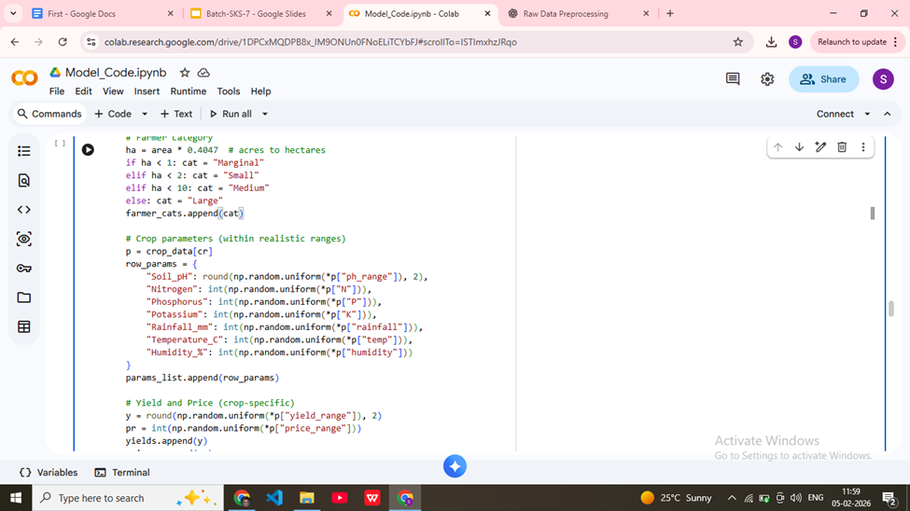

Data Preprocessing

Login Page
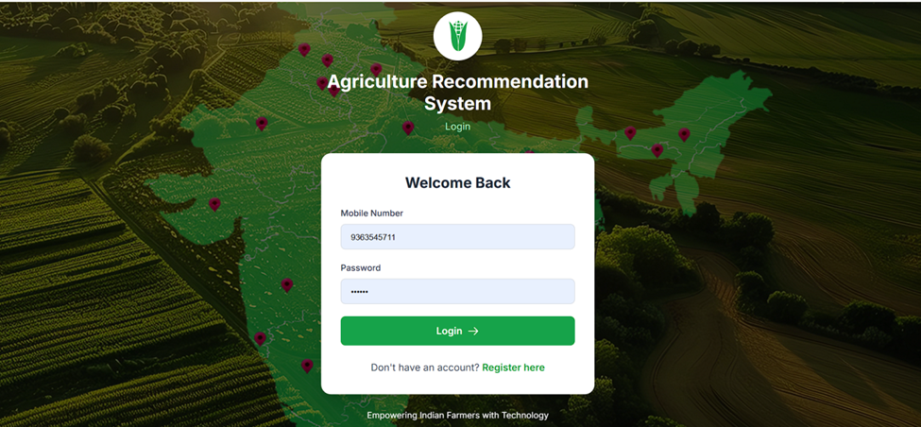

Registration Page
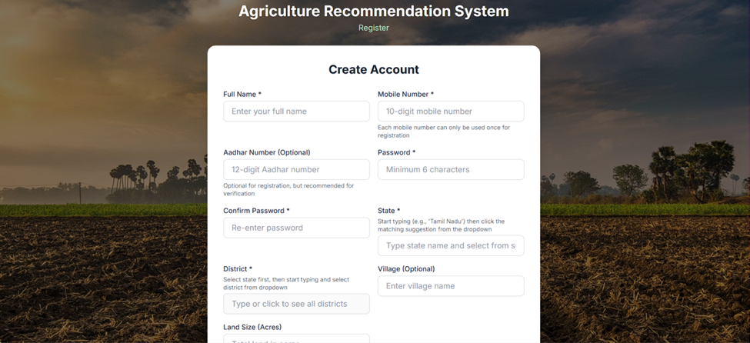

Dashboard 

Recommendation Inputs
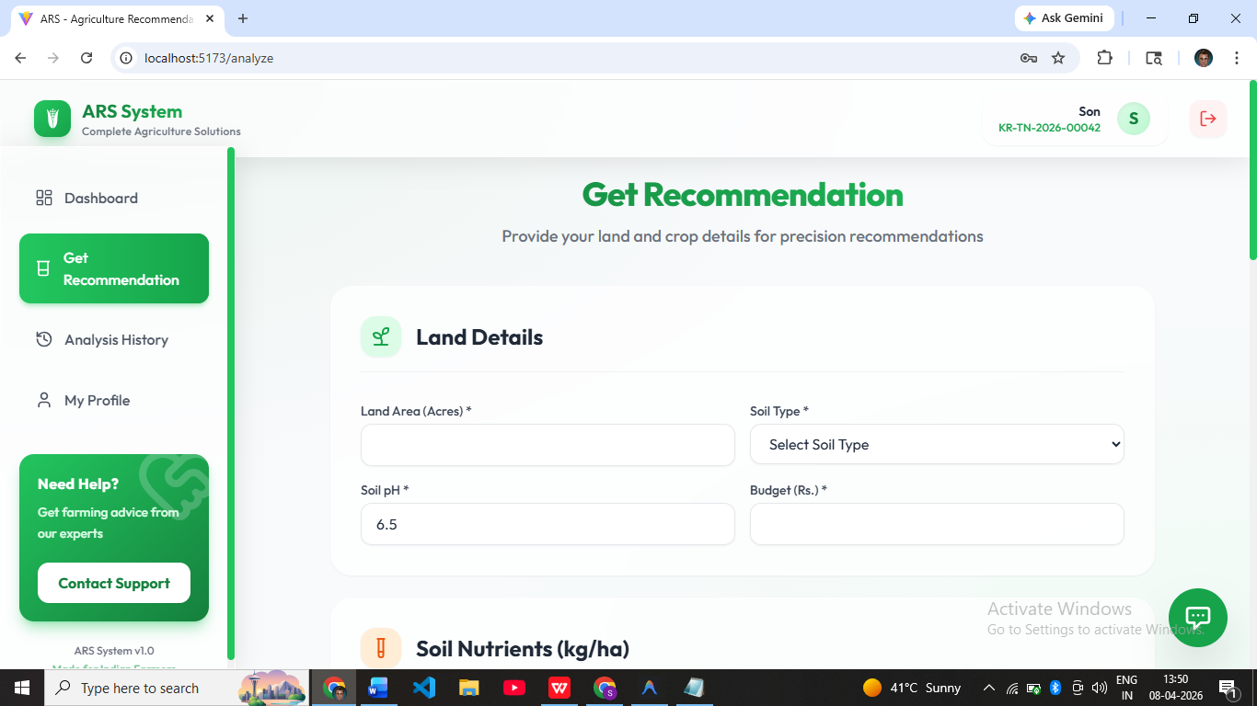
Recommendations
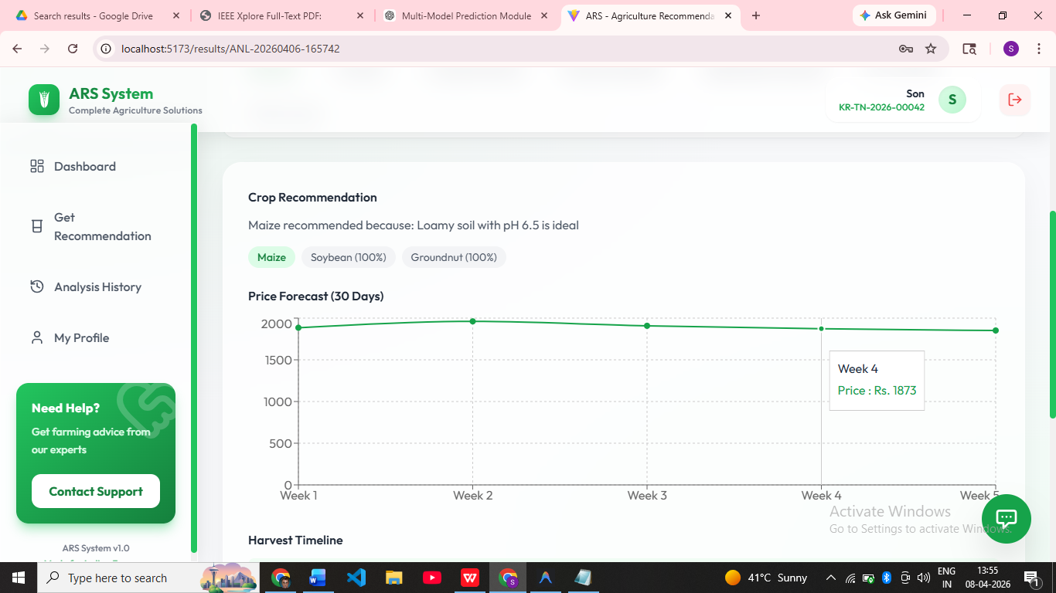

Analysis History
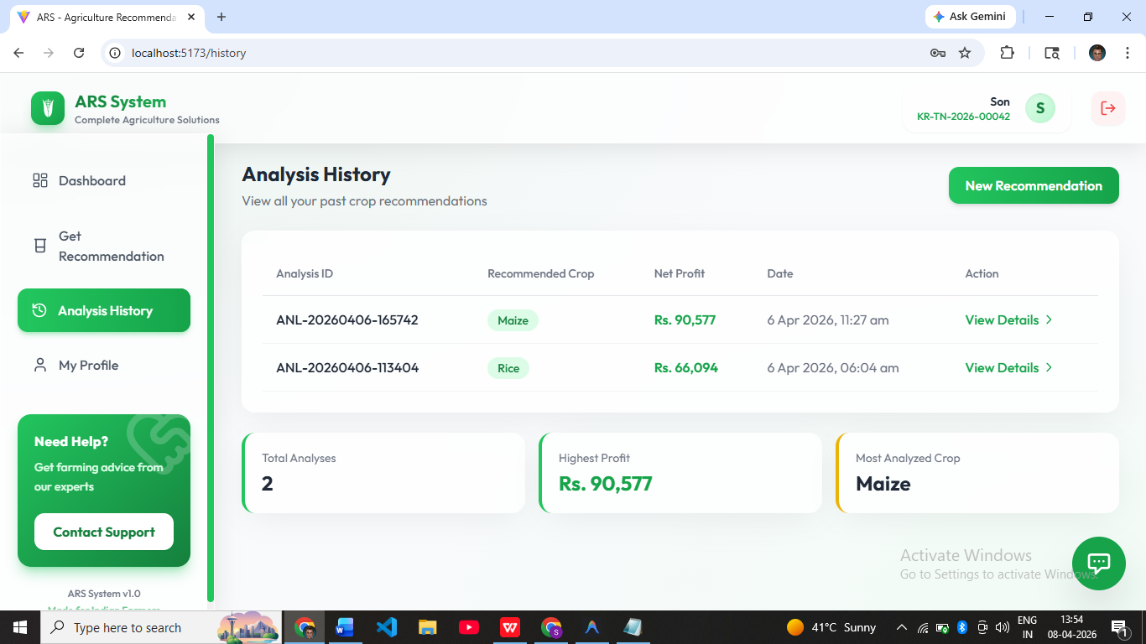

REFERENCES
[1] Neelamadhab Padhy, Rasmita Panigrahi, Sunil Bag, “Application of Intelligent Recommendation for Agricultural Information”, IEEE International Conference on Emerging Systems and Intelligent Computing (ESIC), 2025.
[2] Anamika Dey; Chandranath Chatterjee; Pabitra Mitra; Sadique Amin; Somrita Sarkar, “ GKANs-KNN: Enhancing Crop Recommendations with Deep Learning ” IGARSS 2025 - 2025 IEEE International Geoscience and Remote Sensing Symposium, 2025.
[3] Ahmad Ali, Asad Gulshair; Atif Khan; Ayesha Khaliq; Muhammad Umair; Salman Jan ; “AI-Driven Smart Agriculture: An Integrated Approach for Soil Analysis, Irrigation, and Crop-Fertilizer Recommendations” IEEE Conference, 2025.
[4] Renukadevi S; Sanjay M; “Crop Disease Prediction and Pesticide Recommendation Using Deep Learning Techniques” 2025 International Conference on Data Science and Business Systems (ICDSBS), 2025.
[5] Akhil Kumar M B; Anirudh T G; Chinmay S Jain; Karthik K S; Mallikarjun B C; “ Smart Agriculture with Fertilizer/Pesticide Recommendation System ”, 2025 3rd International Conference on Smart Systems for applications in Electrical Sciences (ICSSES), 2025.
[6] Bixian Cheng; Danni Chen; Ji Li ; Jun Liu : Qing Shen; “A study on the forecasting of agricultural product price trends based on SARIMA”, 2025 IEEE 8th Information Technology and Mechatronics Engineering Conference (ITOEC), 2025.
[7] Anitha C; Kavitha U; Poornachandra T; Rajasekar G; Saravanan T R ; Sathishkumar V E “IoT-based Gradient Boosting Model for Efficient Agricultural Logistics and Transport Management”, 2025 4th International Conference on Innovative Mechanisms for Industry Applications (ICIMIA), 2025.
[8] Claudio Salvadori; Cristiana Caponio; Eddi Lorenzi; Fabrizio Benelli; Franco Maciariello; Giovanna Sangiuolo; “TrackOne: Smart Logistics for a Sustainable and Interoperable Agricultural Supply Chain in the Era of Digitization“, 2025 International Conference on Software, Telecommunications and Computer Networks (SoftCOM), 2025.
[9] Dhivya V ; Rakshitha K ; Sahana; Thanuja A S “ FutureCrop: AI-Powered Price Prediction for Agriculture and Vegetable Markets ”, IEEE International Journal of Scientific Development and Research , 2025.
[10] Lingfang Zhao; Xingbo Yao ; Yan Lu; Yihua Wang; Ziyun Ding; “Simulation of Agricultural Product Price Forecast and Market Analysis Model Based on Time Series Algorithm”, 2024 International Conference on Telecommunications and Power Electronics (TELEPE), 2024.

